Photos of Crane position on Lorry

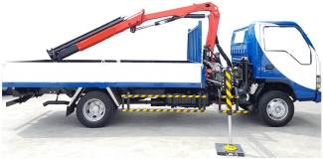
Adequately stowed cranes

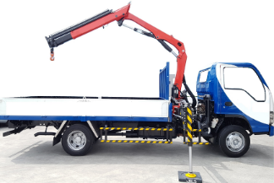
Inadequately stowed cranes
Crane booms above maximum stowed height

